**Facilities & Other Resources**

The institutions comprising this program possess all necessary Facilities & Other Resources including classroom, laboratory, and field resources needed for the successful completion of the proposed project. Our transdisciplinary team has a full range of capabilities needed to complete the research, teaching, and extension activities outlined in this proposal.

***The Center for Renewable Carbon (CRC)*** has offices, classrooms, and laboratories with ample space for the project. The labs are equipped with a full complement, depending on the laboratory type, of standard chemistry, biochemistry, biomass and materials science equipment, instrumentation, and services. The CRC is in two campus locations and houses three units: The Biomass Chemistry Laboratories (BCL), the BioEnergy Science & Technology (BeST) Unit, and the Materials Science & Technology (MaST) Unit. The BCL(2500 ft2) is housed in the Plant Biotechnology Building (PBB, **Fig. 1**) and in the Center for Renewable Carbon building (10000 ft2) and is fully equipped for organic synthesis.

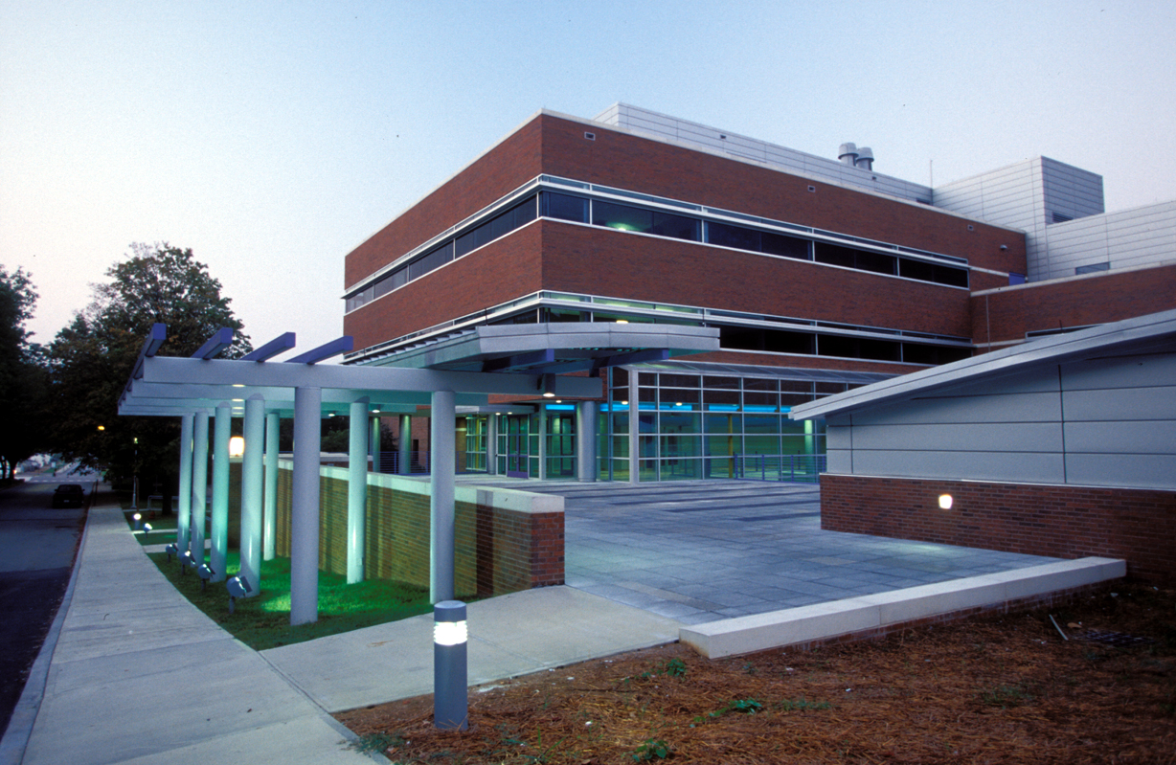

***Figure 1****. The Plant Biotechnology Building at the University of Tennessee.*

PBB is a 133,000 ft2 facility located on the UTIA campus and designed to support advanced research and foster collaborations. The building encompasses four distinct spaces fitted with internet and projection technology: (1) medium-size lecture hall (125 seats); (2) classrooms for lectures (50 seats); (3) laboratory classrooms; and (4) conference rooms (20-30 seats). The facility also contains individual laboratory spaces (approximately 57 @ 500-1000 ft2 each; 81,000 assignable sq. ft.), and offices.

The BCL contains resources directed toward catalyst development, isolation and characterization of intermediates, and structural determination including biomass-based chemicals. Co-PD Labbé’slaboratory is housed in the BeST Lab (8100 ft2), which offers a state-of-the-art laboratory environment for bioenergy and bioproducts research and development. The laboratory includes capabilities for biomass preprocessing, pretreatment, fractionation, thermochemical and biochemical conversion, and products analysis. Unique analytical capabilities for biomass characterization are available via an established partnership with PerkinElmer Inc.

***The Biosystems Engineering and Soil Science (BESS) Department*** provides offices, classrooms, and laboratories that will be leveraged for this project. With focus areas in bioprocessing, land and water science, engineering, soil science, and environmental science, the department houses various resources facilitating the execution of research, extension, and education programs. BESS is housed in three buildings: the BESS office building, a three-story building providing office and meeting spaces for faculty, staff, post-docs, and graduate students; the BESS lab and classroom building, housing research and extension labs, six classrooms, fabrication, electronic, and instrumentation shops, and the analytical laboratory for environmental and biological analysis; and the Third Creek Building, which houses several research labs.

PD Abdoulmoumine’s lab, the **B**iomass conv**E**rsion **A**nd **M**odeling **(BEAM)** laboratory (~2,000 ft2) is housed in the Biosystems Engineering and Soil Science (BESS lab) building and the Center for Renewable Carbon and has capabilities for biomass preprocessing, pretreatment, conversion, and analysis.